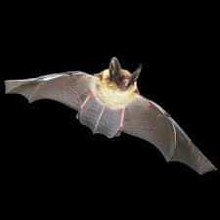
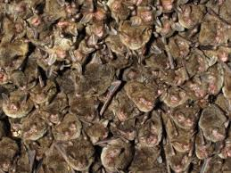

Bat Night at Wallkill River National Wildlife Refuge
August 1, 2026 7:30 pm to 9:00 pm
Rain Date August 8th
1547 County Route 565, Sussex, NJ
136 Owens Station Road
Sussex, NJ

Join us for a free presentation on Bats. Learn about the different species in our area, including migratory bats. This event begins with a presentation indoors, then moves outdoors to listen for bats using an echolocation device. Guests are encouraged to bring headlamps and flashlights and may want to use insect spray if mosquitoes are out.

